# **Task 4 – Creating a Prototype User Interface and Usability Testing (20 marks)**

**Prototype of the Student Business System for College**



***(Figure 4.1: Homepage overview)***

Figure 4.1 shows the website’s homepage. The moment users enter the site, they are greeted with a brief introduction from the campus site before choosing the page they would like to visit. Users can navigate to a particular page by clicking on one of the text button options listed above the background image. For example, clicking on the ‘Members Area’ button will navigate users to the login form.

**Accessing Members Area:**

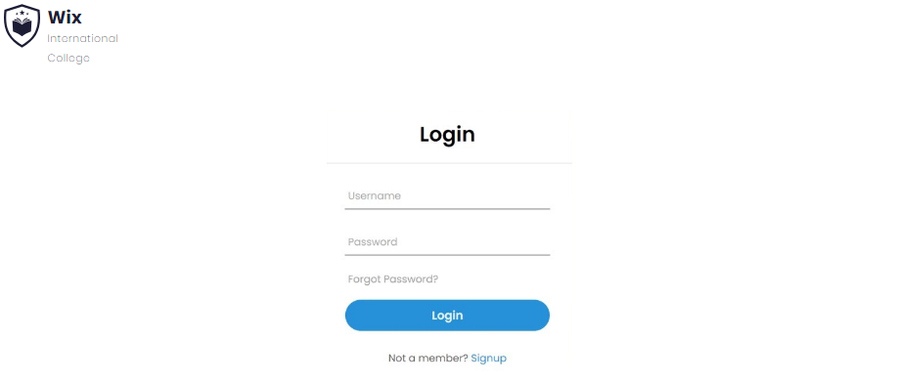

***(Login page of ‘Members Area’)***

This page allows students to login to their existing account or register for a new account using the ‘Signup’ button.

**Accessing course materials:**

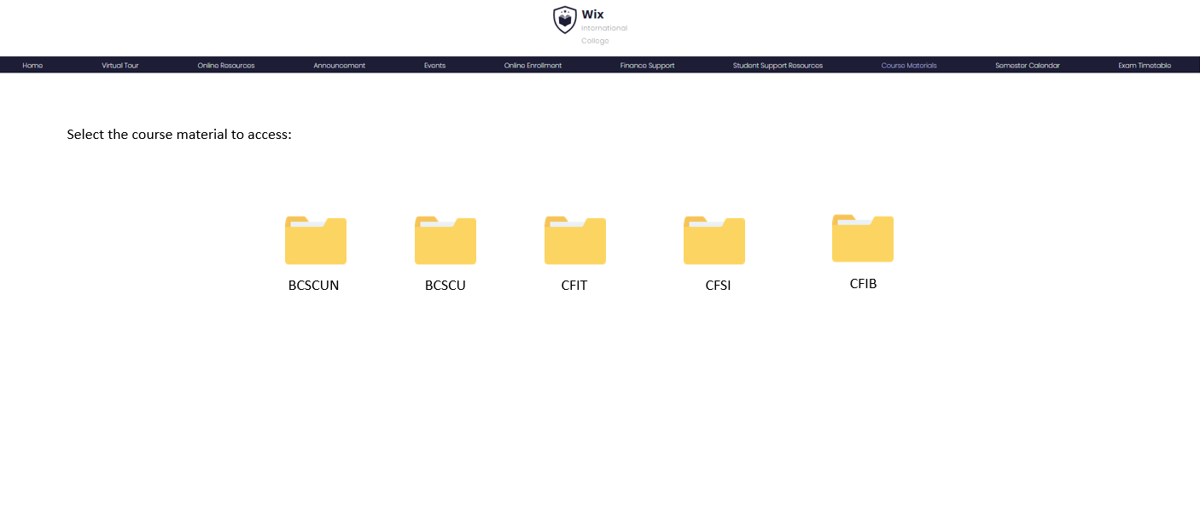

***(Figure 4.3a: Course materials page)***

This page allows students to access all course materials used by lecturers during lectures and tutorials. Clicking into a specific folder will display lecture slides, course structures, course exercises, and past-year papers.

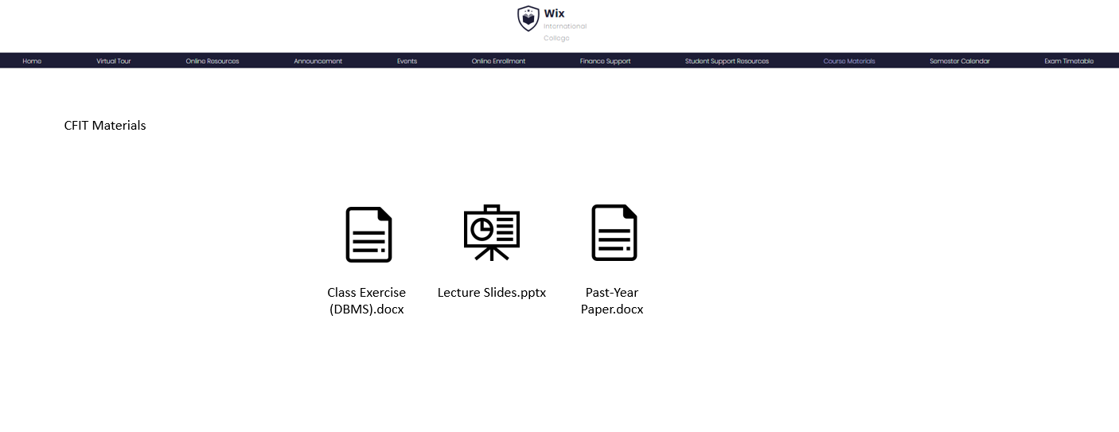

**(Figure 4.3b: Course Materials (CFIT))**

**Usability Testing**

|  |  |  |  |
| --- | --- | --- | --- |
| **Scenario** | **Test Description** | **Task** | **Expected Outcome** |
| Registering a student account | Creating a student account which can be used to access services offered by the college | Create a student account using student email and password | System will register user credentials into the database and prompt a success message on the screen |
| Registering a student account using mismatched passwords | Creating a student account using mismatched passwords in the ‘Password’ and ‘Confirm Password’ fields | Create a student account using different passwords for the ‘Password’ and ‘Confirm Password’ fields | System will display an error message saying passwords do not match |
| Registering an existing student account | To verify that the system will reject any attempts to register a new account using an existing email | Create a new student account using an existing student email | System will display an error message saying that student account already exist |
|  |  |  |  |
| Login to student account | Signing in to the student account created prior to this test scenario | Entering student email and password into relevant fields | System recognises student’s account and proceeds to log them in |
| Login to site using invalid credentials | To verify that the system will reject any attempts to login to the site using invalid email or password | Entering an invalid student email and password | System displays an error message saying invalid email/password |
| Enrolling into a course | Allowing students to enrol into their desired course through the site | On the ‘Online Enrollment’ page, select the course code users wish to enrol in | Students will successfully be enrolled into their desired course |
| Dropping from an enrolled course | Allowing students to drop a specific course through the site | On the ‘Online Enrollment’ page, select the course code users wish to drop out from | Students will successfully drop out from the course |
| Accessing course materials | To evaluate the efficiency of accessing specific course materials | Click on the ‘Course Materials’ button to select the course folder | Users will be able to view course structure, lecture notes, course exercises, and past-year papers |
| Viewing course materials | Allowing students to view course content online without having to download it to their local device | Upon entering the course folder, click on any file to access its material | The course material will be displayed on the site itself |